**American International University-Bangladesh (AIUB)**

**Department of Computer Engineering**

COE 3201: Data Communication Laboratory

**Lab Report 2**

**Title: Study of signal frequency, spectrum, bandwidth, bit rate, quantization using MATLAB**

**Supervised By**

**SADMAN SHAHRIAR ALAM**

## Submitted By

|  |  |
| --- | --- |
| **Name** | **ID** |
| **MD SAMIN YEASAR** | **22-47139-1** |

## Group Members

|  |  |
| --- | --- |
| **Name** | **ID** |
| **MD. JOBAER HOSSAIN** | **22-47116-1** |
| **RIFAH SANZIDA** | **22-47154-1** |
| **SHAYAN ABRAR** | **22-47156-1** |

**Ans the questions**

**ID: AB-CDEFG-H**

**ID: 22-47139-1**

**a**

A1 = GD = 97

A2 = AF = 23

A1 = 16; % Amplitude of first signal

A2 = 5; % Amplitude of second signal

x1(t) = A1 cos(2π(C*100)t )

x2(t) = A2 cos(2π(F*100)t)

**b**

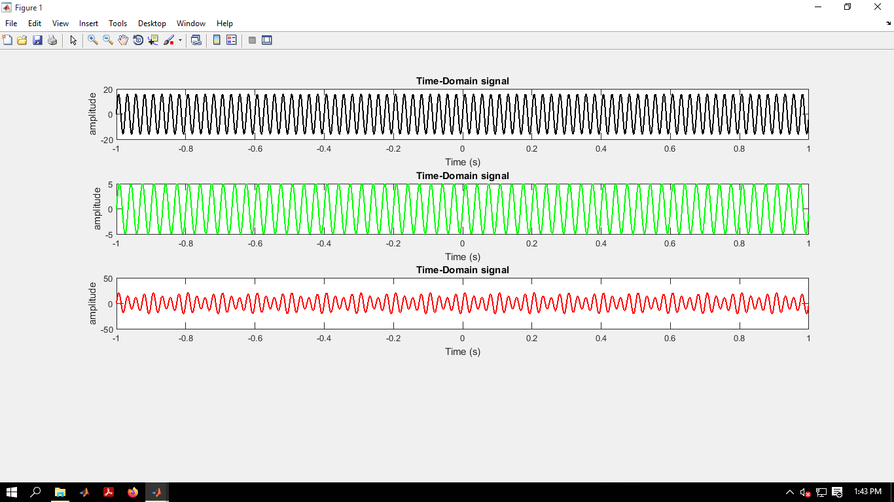

fs = 10000; % Sampling frequency

t = 0:1/fs:1-1/fs; % Time duration

C = 40; % Frequency of first signal

F = 30; % Frequency of second signal

A1 = 16; % Amplitude of first signal

A2 = 5; % Amplitude of second signal

x1 = A1*sin(2*pi*C*t); % First Signal

subplot(3,1,1)

plot(t,x1,'k','LineWidth',0.3)

title('Time-Domain signal');

xlabel('Time (s)');

ylabel('amplitude');

x2 = A2*sin(2*pi*F*t);

subplot(3,1,2)

plot(t,x2,'g','LineWidth',1.5)

title('Time-Domain signal');

xlabel('Time (s)');

ylabel('amplitude');

x3=x1+x2;

subplot(3,1,3)

plot(t,x3,'r','LineWidth',1.5)

title('Time-Domain signal');

xlabel('Time (s)');

ylabel('amplitude');

**c**

fs = 10000; % Sampling frequency

t = 0:1/fs:1-1/fs; % Time duration

C = 40; % Frequency of first signal

F = 30; % Frequency of second signal

A1 = 16; % Amplitude of first signal

A2 = 5; % Amplitude of second signal

x1 = A1*sin(2*pi*C*t); % First Signal

subplot(4,1,1)

plot(t,x1,'k','LineWidth',0.3)

title('Time-Domain signal');

xlabel('Time (s)');

ylabel('amplitude');

x2 = A2*sin(2*pi*F*t);

subplot(4,1,2)

plot(t,x2,'g','LineWidth',1.5)

title('Time-Domain signal');

xlabel('Time (s)');

ylabel('amplitude');

x3=x1+x2;

subplot(4,1,3)

plot(t,x3,'r','LineWidth',1.5)

title('Time-Domain signal');

xlabel('Time (s)');

ylabel('amplitude');

fx3 = fft(x3);

fx3 = fftshift(fx3)/(fs/2);

f = fs/2*linspace(-1,1,fs);

subplot(4,1,4)

plot(f, abs(fx3),'LineWidth',1.5);

title('magnitude FFT of sine');

axis([-100 100 0 20])

xlabel('Frequency(Hz)');

ylabel('magnitude');

cx = x1+x2+x3;

bandwidth = obw(cx,fs)